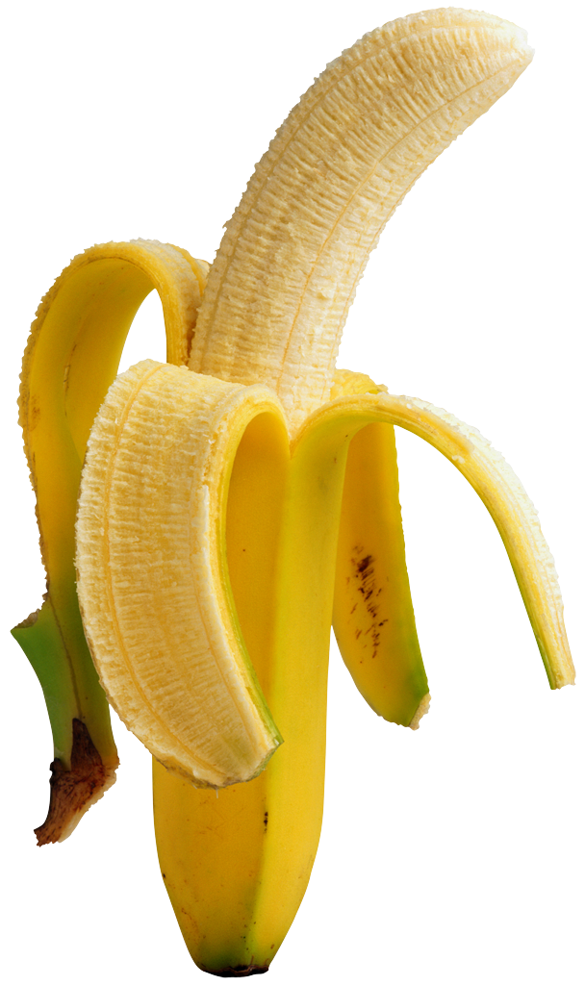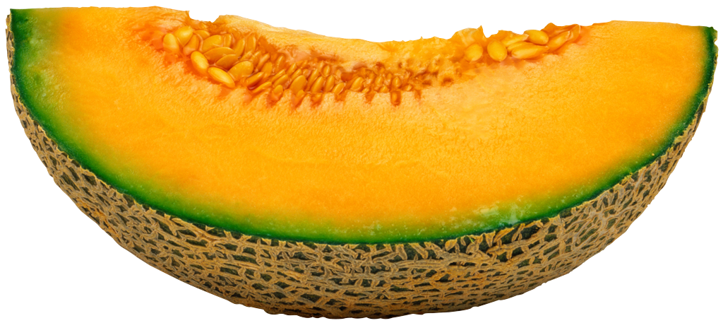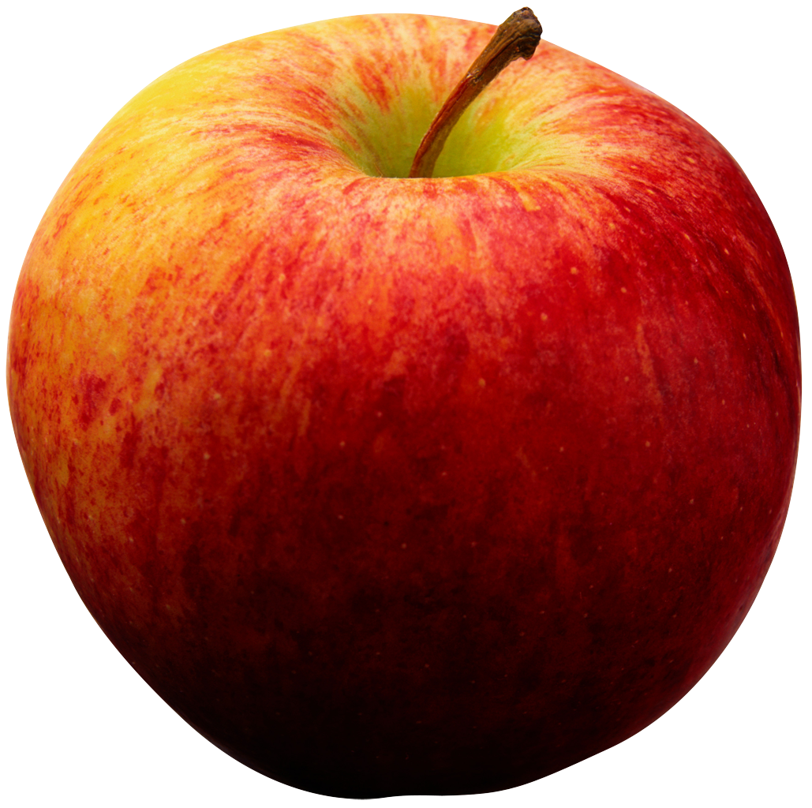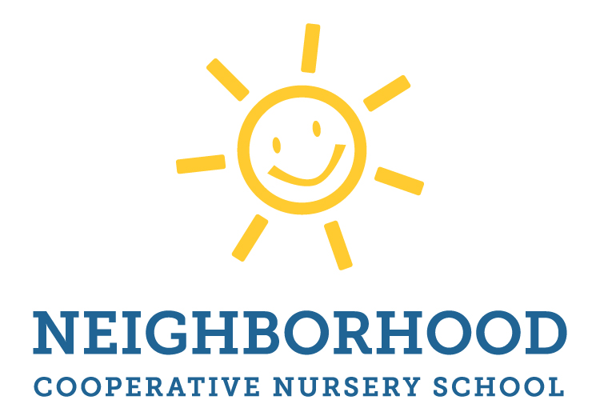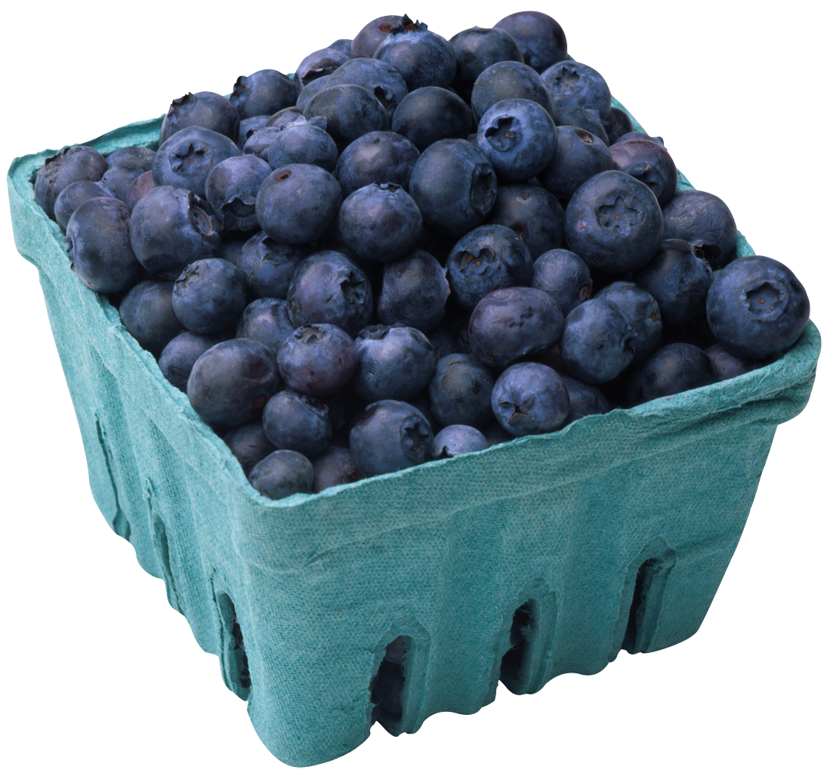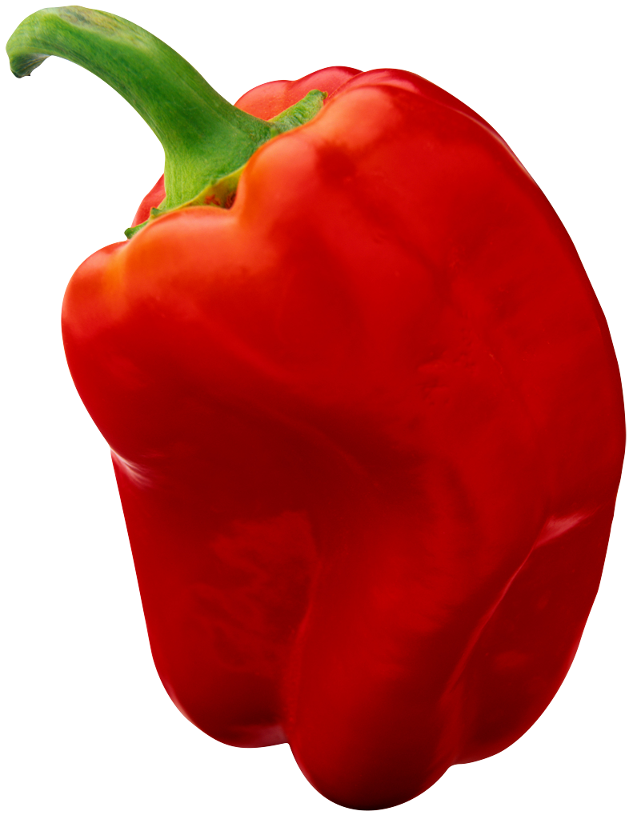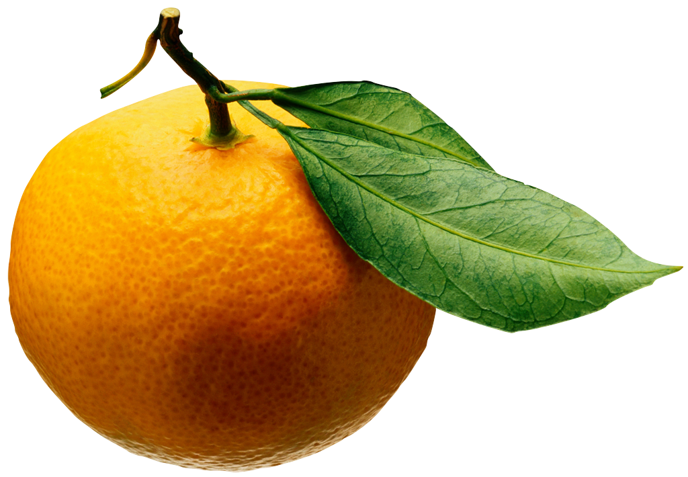

Safe and Healthy Snack Ideas

The Neighborhood Cooperative is a “nut-free zone” this means that snacks must not be made with nuts OR manufactured in a plant with nuts. Read the label because it SHOULD tell you how it was manufactured (although it is not required). Some products with nuts are obvious to identify like peanut butter flavored candy or snack bars, trail mix, or almonds. However, other snacks may not have nuts identified in the title or may have been cross contaminated on shared equipment. While this may not seem like much to some, even a cross with peanut dust can be enough to put a child in distress so please be mindful and choose options that are totally nut-free.

*** A note about birthdays and special celebrations: We ask that you please stick to bringing a safe nut free snack***
*** Although baking with young children is a valuable experience, we ask that you please bring produce or items that are prepackaged so that we can ensure they are safe for all of our students***

Does It Make the Healthy School Snacks List?
When choosing healthy nut-free snacks, it is always important to check the label before purchasing as brands continuously change their manufacturing process.
The best way to determine if foods are allergy-free snacks is to read the label since most brands have a warning statement or allergen list. Be aware of phrases like this:
“May Contain Peanut or Tree Nuts”
“Processed on shared equipment with Peanuts or Tree Nuts”
“Manufactured in a plant with Peanut or Tree Nuts”
“Contains Peanut or Tree Nut Ingredients”

Produce
- Fresh fruits (apples, oranges, banana, cut grapes, watermelon, cantaloupe, pear, kiwi, blueberries, etc.)
- Fresh vegetables (carrots, celery, broccoli florets, bell pepper strips, cut cherry tomatoes)
- Applesauce cup or pouch
- Canned fruits and vegetables (look for “in it’s own juice” or “in water”)
- Mandarin orange fruit cup
- Raisins
- Dried Fruit

Peanut Butter-Free and Nut Butter-Free Spreads and Dips
- Sunbutter
- Soy Nut Butter
- Plain hummus (read the label)
- Guacamole

Salty
- Roasted Chickpeas
- Crackers (Wheat Thins, plain Triscuits, Goldfish)
- Pretzels (Newman’s Own, Rold Gold, Pepperidge Farm Pretzel Goldfish)
- Rice cakes
- Goldfish/Cheddar bunnies
- Potato chips (popchips, Baked Lay’s, Cape Cod, Baked Lay’s, Pringles, Ruffles, Kettle Brand)
- Late July Organic Tortilla Chips

Dairy
- Yogurt tube
- Pudding cup
- Yogurt pouch
- Cheese (stick, cube, round, slice)
- Yogurt cup (*read the label and be aware of yogurts that also contain watch out for granola or cookies)

Sweet
- Graham cracker
- Teddy grahams
- Nilla wafers
- Fruit leather (homemade or store bought)
- Fruit snacks
- Oreos
- MadeGood Granola Bars
- MadeGood Krispie Squares

Simple Recipes
- Guacamole (avocado, lime juice, cilantro)
- Fruit Kebabs/ Fruit Salad
- Fruit and Cheese Kebabs
- Caprese Skewers (tomato, basil, mozzarella ball)

